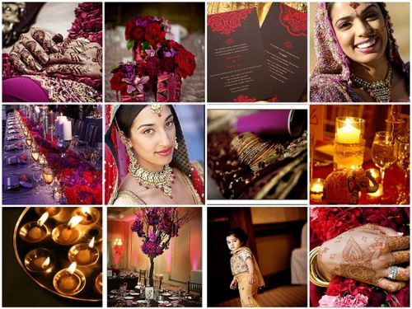

Wedding Photography

Business

**INDEX**

Preface……………………………………………………………..3

Acknowledgement………………………………………………...4

What is Photography……………………………………………...5

Types of Photography…………………………………………….5

Main Focus : Wedding Photography…..………………………..7

History of Wedding Photography………………………………..7

Current trends in Wedding Photography……………………….8

Communication between Customer and Business system…..10

Studio’s Infrastructure……………………………………………12

Departments of Photography……………………………………13

1. Sales Department…………………………………....15
2. Capture Department…………………………………20
3. Editing and Designing Department…………………25
4. Developing and Printing Department………………30
5. Purchase Department……………………………….35
6. Accounts Department ………………………………40

Resources………………………..………………………………43

**Preface**

The professional study is the internal part of the B.C.A. programme of MS University. It helps the students understand practical aspects of a Business Domain in a better way.

We were required to undertake the detail study of the activities of a photography business as a whole and its department. It helped us to apply theoretical knowledge into practical experience. We studied different studios which have modern infrastructure and modern equipments. We have collected information from Expert Photographers, Editors, Designers and Printers.

**ACKNOWLEDGEMENT**

We have been able to prepare our report successfully and we acknowledge a special thanks to Mr. J.P. Patel and all those people who helped us during our project. It has been an enriching experience for us to undergo our project which would have not been possible without the goodwill and support of the people around.

We would hereby take this opportunity to show our gratitude towards our mentor for what we have learnt during our project. A good response, feedback and co-operation given by the Studios we visited helped us in gaining knowledge and solving our queries. We convey our sincere thanks to all the officials of the Studios.

We are also extremely thankful to our B.C.A Programme for giving us this opportunity which will be helpful for us in our career ahead. We express our sincere thanks to The Co-ordinator of B.C.A Programme, Dr. V.A.Kalamkar who guided us throughout our project.

**What is Photography?**

The art of processing and producing images on photosensitive surfaces.

A digital photography workflow is an end-to-end system of working with digital images, from capture to delivery. It is comprised of a series of inter-connected steps developed by photographers to simplify and standardize their work.

**Types of Photography**

1. PHOTOJOURNALISM:

Photojournalism is an area of photography dedicated to taking accurate shots of current events. The basic mission of a photojournalist is to take pictures to accompany a news story. Pictures should tell the story before the text or broadcaster does.

1. WILDLIFE PHOTOGRAPHY:

Wildlife photography is the act of taking photographs of wildlife. It is one of the most challenging types of photography. Photographer needs sound technical skills. Some animals are difficult to approach and thus knowledge of the animal’s behavior is needed in order to be able to predict their actions.

1. SPORTS PHOTOGRAPHY:

Sports photography is one the fastest and most exciting types of photography. As with any action shot, a good photographer has to know his/her subject well enough to anticipate when to take pictures.

1. WEDDING PHOTOGRAPHY

Wedding photography is a blend of different types of photography. For example, Photographer might have glamour photography techniques to capture the bride and groom at their best. Although the wedding album is a documentary of the wedding date, it can be edited and can produce beautiful images.

1. NATURE PHOTOGRAPHY

Nature photography refers to a wide range of photography taken outdoors and devoted to displaying natural elements such as landscapes, wildlife, plants and close-ups of natural scenes and textures. This photography tends to put a stronger emphasis on the aesthetic value of the photo than other photography genres.

1. FASHION PHOTOGRAPHY

Fashion photography concentrates on taking pictures of clothing and accessories (on models or alone) to be published in fashion magazines, advertisements or circulated among designers.

**OUR MAIN FOCUS: WEDDING PHOTOGRAPHY BUSINESS**

* Wedding photography deals with capturing real moments of a couple’s most important event in life.
* Everything is live and needs to be captured in one go.
* Real life moments do not have retakes.
* This field is booming and developing very rapidly and thus new software demands keep growing.

**HISTORY OF WEDDING PHOTOGRAPHY**

The history of wedding photography begins in the early 1840s. During this period, photography had very little commercial use, but the idea of creating memories of the wedding day was already born.

Due to the equipment limitations in the 1800s, there was only a portrait on a tiny copper sheet, not like today have paper photographs, multiple photographs, and albums. However, as the years passed, technology changed how photographs were produced and presented. In the beginning of the 20th century, the color photographs became possible, but the production process was not developed well until the 1950's. Colors shifted and faded after a short period of time, so photographers continued to work with black and white films.

However, after that period, the portability of small, newly designed cameras was born. Photographers using their new portable roll film based cameras and compact flashbulb lighting to shoot a wedding event and then try to sell the photos to the bride and groom. Despite low quality results, the competition is very fierce in this industry. Therefore, it forced the studio photographers to start working on location. Trying to imitate the studio settings, photographers would have to bring heavy photography equipment and bulky lighting to wedding locations.

Before the early 1970s, it was practically the only style of wedding photography that is with beautiful poses created in a studio or on location using studio quality lighting. It was called traditional wedding photography style, and this style has been practiced for more than a hundred years. However, a dynamic change in the photo industry evolved changing the traditional wedding photography style into a new style called wedding photojournalism or documentary style: in other words, the style which captures the wedding as it unfolds.

While both styles have advantages and disadvantages, neither of them are the primary style for most professional photographers today. Clients began requiring a mixed or blended style of wedding photography now. And with the invention of digital photography, new creative opportunities emerged. Digital cameras allow deeper reportage of the event with unlimited amount of photographs taken, and great design opportunities. It is obvious that the future belongs to digital photography.

**Current trends in wedding photography**

Wedding photography is an embryonic ground that requires imaginative talent, visualization, and highly technological expertise. In the past wedding photography always related to the limited stiff posses without much regard for the underlying tale, sentiment, romance, and behind the scene events of the wedding day.

Nowadays the modern wedding couple asks for more fashionable approach for their wedding days. Wedding photojournalism is in vogue for the last decade. The main idea behind it has been to capture the wedding event exclusive of any interference or direction from the wedding photographer. The photographer is there to capture the real essence of that day. In the result of this practical approach the capturers are a true representation of the wedding day.

A number of photographers offer a hybrid approach to wedding photography, usually a blend of traditional and journalistic wedding photography. In this approach the photographer mainly focuses on documenting the wedding event but this coverage also includes a session with the couples for formal posed or semi-posed pictures along with the family group photographs. These days half the photo is made on the camera with the half of the photos are achieved through digital image artistic editing and manipulation.

**Communication between Customer and Business system:**

Firstly, customer comes to Sales counter to inquire about different packages of wedding photography. Sales person explains different packages to customer. The information about packages will be covered later. According to customer’s requirements they select package and inform their wedding date. Sales person checks whether the date is available or not. If unavailable then customer opts for other package if they wish. Customer can have some extra facilities by paying for them.

On the wedding day, photographers reach venue little early to setup for capturing photos and shooting videos. Later, customer will be called to the studio for selection of photos so he/she can decide which photographs they want in their final wedding album. The finalized album is delivered on the date which is already specified by Sales Manager to the customer.

**Activity diagram which represents communication between customer and Business system**

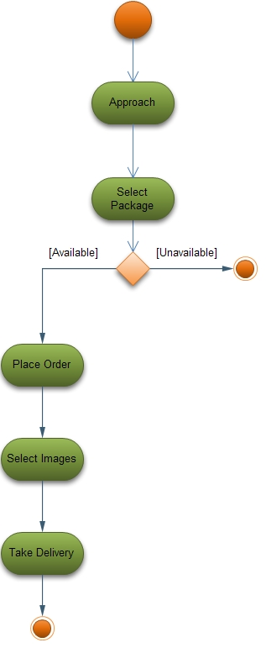

**Studio infrastructure:**

When studio gets an order and advance payment from customer then first Sales Manger prepares schedule for that order in which he/she assigns work for each department and gives time limit to them.

On the wedding day, photographers and their assistants reach venue little early so that they can setup tools and make connections. Photographers capture images and shoot videos on the wedding day.

After that, photographers select images which they like and discard improper images. They send these images to manager. Manager calls customer to studio to select images from selected images by photographers.

The selected images are sent to Editing and Designing Department. Editors do cutting and correction of images as per requirements, and for videos, they render and burn it onto disc. The prepared disc is sent to Sales Department for delivery. Designers design images for album and send it to the Manager. He/She forwards it to Printing and Developing department.

Here actual printing of images is done and then binds it into album. This finalized album is sent to Sales department from where customer collects it and does payment on the delivery date.

During this process, if any material is required then respective department sends requirement list to Purchase department. They will provide material to respective department in time and sends all bills to Account department which does entries in appropriate account. Account department also pays salary to studio’s employees.

**Departments of Studio**

1. **Sales Department**:

Workers of Sales Department takes order from the customers and provide them information about their requirements and deliver them the final product which passes through all departments.

1. **Capture Department:**

In Capture Department, according to the requirements of the customers, photographers capture the live moments and pass it to the Editing and Designing department.

1. **Editing and Designing Department:**

Editors make changes to the image which are captured by the photographer, and make the image attractive and then Designer place the images in proper manner in the album.

1. **Developing and Printing Department:**

Actual photo developing and printing is done in this department.

1. **Purchase Department:**

Members of this department buy the equipment like Cameras, Lights, Tripods, Albums, etc. for studio.

1. **Account Department:**

In this department, financial transactions are maintained and salary payment is also done by this department.

**Communication between departments**

Account Department

Sales Department

Purchase Department

Capture Department

Editing & Designing Department

Developing & Printing Department

**Detail information about Departments**

1. **Sales Department**

The main work of Sales Department is to handle customers of the studio and maintain relation between client and Studio.

MAIN OBJECTIVES :

* To handle customers of Studio.
* To get order and deliver order in time
* To maintain good relations between client and Studio.
* To try to increase Studio’s business.

WORK FLOW :

* First customer comes to sales counter of Studio. The person who stands at counter handles the customer. He/she explains the different packages which are available at their studio.

Different packages:

1. Silver – Rs 50,000

In this package, one expert wedding photographer is provided on the wedding date. Number of photographs will be around 200. Printing will be done in studio itself.

1. Gold – Rs 75,000

In this package, two expert wedding photographers are provided on the wedding date. Number of photographs will be around 500. Photographs will be sent to Canvera, Bengaluru for printing and binding.

1. Platinum – Rs 1,00,000

In this package, expert photographers are provided according to the venue like how big it is. Number of photographs will be around 750 and a storybook album for the couple. Photographs are sent to Graphi Lab, Italy for printing and binding.

In these packages, printing and binding differs in quality. Quality and attractiveness of albums and durability of the album differs. For example, Silver package albums stays for around 30 years, Gold package albums stays for around 50 years and Platinum package albums stays for around 100 years.

Some extra facilities like making small storybook for the couple are also provided by studio but they charge extra for it.

* Customer selects one package according to his/her requirement.
* After getting order, Manager of Sales Department makes schedule for the order. He/she decides when customer will get his /her order’s delivery.
* While making this schedule, Manager takes care of the dates on which photographers are free, workload of editors, designers and Printing Department.
* After making schedule. It’s his job to make sure that everything works according to the schedule. They inform the delivery date to customer so that he/she has an idea about when they will get actual products. Customer will collect his/her order from Sales counter where he had placed order.

It is Sales Department’s responsibility to maintain good relations between client and Studio so that he/she will come back in future for their orders.

Sales department is also responsible for giving advertisements and doing innovative works to increase Studio’s business.

**Actors:**

Customer

**Business Actors:**

All Departments

**Business Workers:**

Sales Manager

Receptionist

Staff

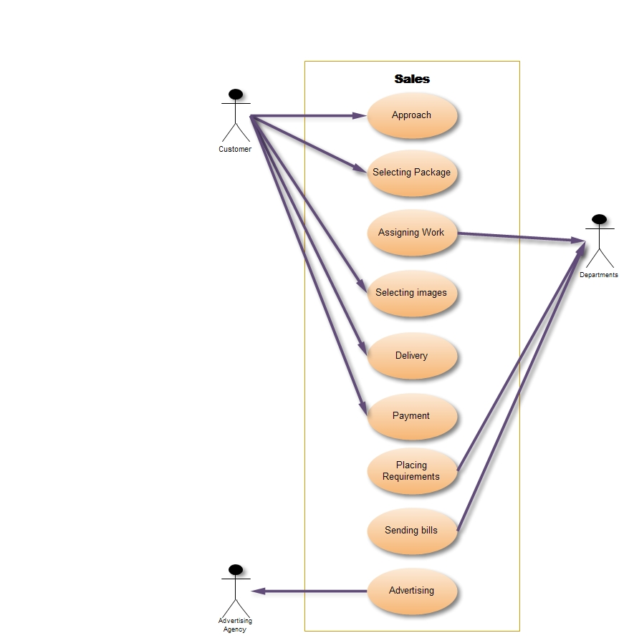

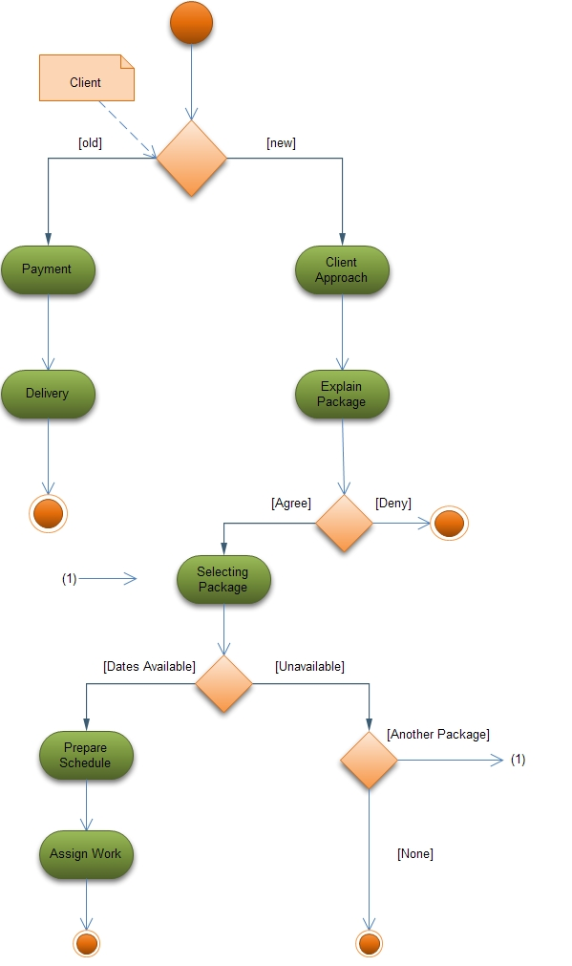

1. **Capture Department**

This is the department where actual capturing of pictures and recording of video is done.

MAIN OBJECTIVE :

* To capture/shoot live precious moments.
* To select good photographs.

WORK FLOW :

* Capture department receives details of wedding to be captured by the Manager of the Sales department.
* If the wedding is out of station, it makes a call to travelling agent and books ticket of the date which is a day prior to wedding date so that photographers can visit and study the site to get an idea of how to go about on wedding date.
* On the wedding date, photographers and their team reach the venue little early so that they can setup lights, make connections and get ready for capturing and recording.
* While taking photographs and video, photographers use a blend of traditional and journalistic wedding photography. The photographer mainly focuses on documenting the wedding event but they also include a session with the couples for formal posed or semi-posed pictures along with the family group photographs.
* After taking pictures and videos, photographers select pictures they like and discard improper pictures like blurred images.
* Selected pictures are sent to Manager who later forwards it to Editing and Designing department.

**Business Actors:**

Sales Manager

Travel Agent

Purchase department

**Business Workers:**

Photographer

Assistant photographer

Extra Staff

**Tools:**

Cameras:

1. Photo Camera:

SLR (Single Lens Reflex): This type of camera is used in low budget events. It contains 35mm Negatives, size of sensor is “APC C” size and around 10mega pixels.

DSLR (Digital Single Lens Reflex): This type of camera is used in High budget events. It captures image digitally, which used CCD (Charge Couple Device).

1. Video Camera:

DV (Digital Video): These Cameras are used for low budget events. It has the resolution size of 720x576 pixels.

HD (High Definition): These Cameras are used for High budget events. It has resolution size of 1280x576/1440x1080 pixels.

HDV (High Definition Video (Full HD)): These Cameras are used for Capturing pictures in 1920x1080 pixels of resolution size.

Lenses:

1. Prime Lens:

These Lenses are used for SLR cameras and used for low light and sharpness.

1. Full Frame Lens:

These Lenses are used for DSLR cameras which has 2.8 full lenses.

Tripods:

This equipment is used with camera for capturing smooth and constant images and video.

Lights:

Used to provide proper lighting for capturing perfect shots.

**Use case Diagram**

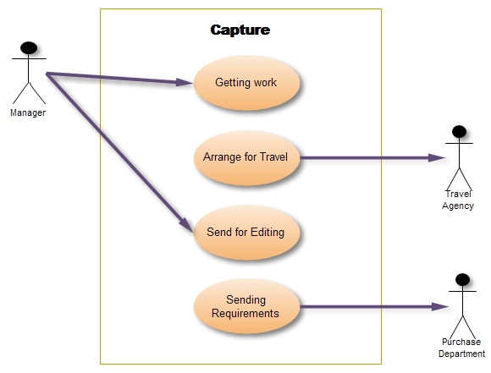

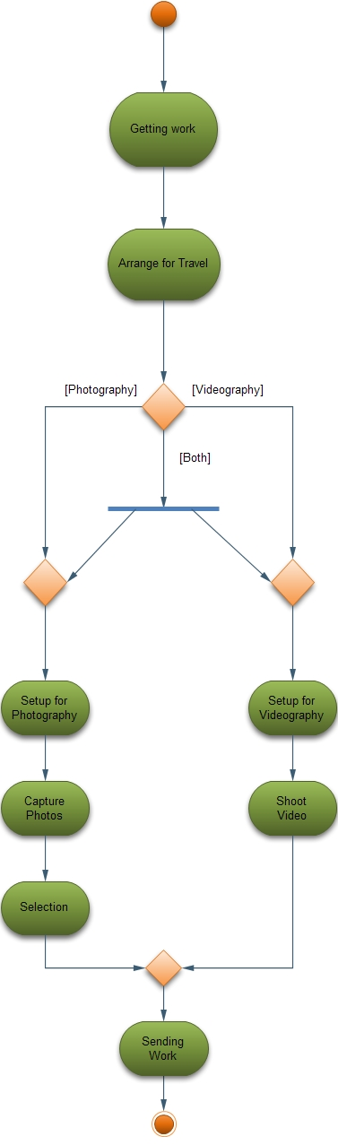

1. Editing and Designing Department

This is department where editing and designing of the images is done according to the type of album selected. Videos are also edited here.

MAIN OBJECTIVES :

* To edit the images/video.
* To design album.
* To prepare final video.
* To deliver images/video on time.

WORK FLOW :

* The Capture department after selection of the images submits it to Manager who sends it to this department.
* After completing the pending work the editor will start working on the given new wedding project.
* Manager gives information to editors and designers about the family members so that they know whom to mainly focus.
* Editor then make changes as required e.g. Selection, Image size alteration, Cropping, Noise reduction, Removal of unwanted elements, Image Orientation, Sharpening-Softening images and color correction.

In Selection, the required portion of the image is selected. For example, selecting portrait of couples.

Image size alteration means changing the size of image. Cropping involves selecting the required amount of image and deleting the unnecessary area.

Noise reduction involves removal of particles like noise with no coherence or coherent noise introduced by the device’s mechanism or processing algorithm.

Image Orientation means rotating the image in required direction.

* After editing of images they are designed and arranged properly according to the album size told by manager e.g. 12 x 18, 12 x 30, 12 x 36 etc.
* Then designed album is sent to the manager who further forwards it to Printing & Developing Department.

**Business Actors:**

Sales Manager

Purchase Department

Developing and Printing Department

**Business Workers:**

Editor

Assistant Editor

Designer

**Entity:**

Computer

Software

Examples:

Aperture

Aperture is software available for Apple Macintosh Operating System. It is professional software that is basically meant for color correction. It provides great tools for correction. Mostly editors having Apple Machine use Aperture for perfect correcting images.

Karizma classic

It is software for designing album. In this software there are readily available templates designed by the company so that designer can directly insert images to form complete designed album. Karizma classic also provide the facility to design and create our own templates. This software is basically meant for fast & quick designing images.

Adobe Photoshop

This software is at the top of the photo editing software. It provides the all the photo editing functionality from basic correction to designing images. Designing is done manually in this software which is very time consuming task. The main problem arises in adobe Photoshop is it takes too much time for editing & designing images.

**Use-Case Diagram**

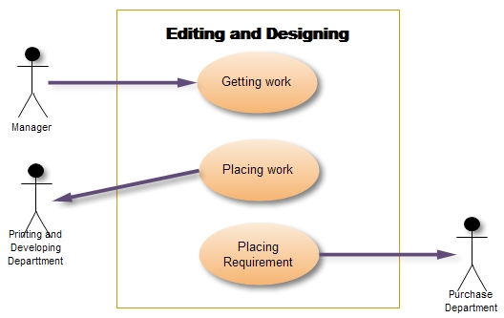

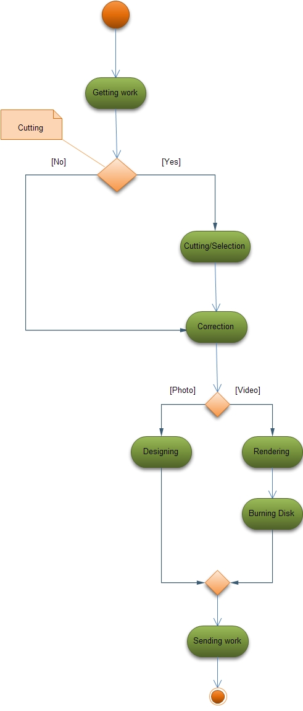

1. **Developing & Printing Department**

This department deals with actually printing of photographs.

MAIN OBJECTIVES :

* To develop images.
* To print Images in proper format.

WORK FLOW :

* The manager sends the designed images to this department.
* After getting the image they are properly sorted in order of the designed images.
* After proper arrangement, image is corrected and placed in queue for developing and then printing.
* If it is a roll then it is developed in dark room and is processed with chemicals. Bleach stabilizer is used to convert them into negative.
* After getting images in negative it is scanned with Negative Scanner to get them into computer for printing.
* After getting the image into computer it is sent to printer for printing. Cartridge is used for printing.
* Every machine has different color format, so it is set with the editor’s machine using the calibrator (Densitometer).
* Printing machine is set at nearly 25-30 degree Celsius.
* Printing is done in total darkness. If by chance some light comes in then the paper gets blocked. It has to be removed and new paper is inserted in machine.
* Images are printed according to the given size. For example, 4 x 6, 8 x 12, 12 x 24, 12 x 30, 12 x 36.
* Images are printed in sheets as instructed by the manager. Three types of sheets are used. They are matte, glossy or acrylic.
* Machines that are used for printing are mainly manufactured by Fuji, Nauricso, Konica.
* Due to heat, the machine becomes slow or gets hanged. Thus, proper maintenance is must.
* Sometimes it might happen that the computer connected to printer gets infected with virus then the printer does not print proper images. Thus, photosensitive papers, chemicals and cartridges get wasted.
* The printed images are properly sorted in order and then bind into album.
* The album is submitted to the manager of the Sales department.

**Business Actors:**

Sales Manager

Editing and Designing Department

Printing Company

**Business Workers:**

Printer

Technician

Sorter

**Tools:**

Scanner

Chemical

Printer

Calibrator

Air-Conditioner

**Use case Diagram**

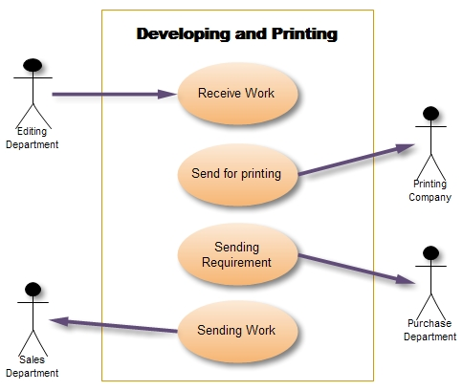

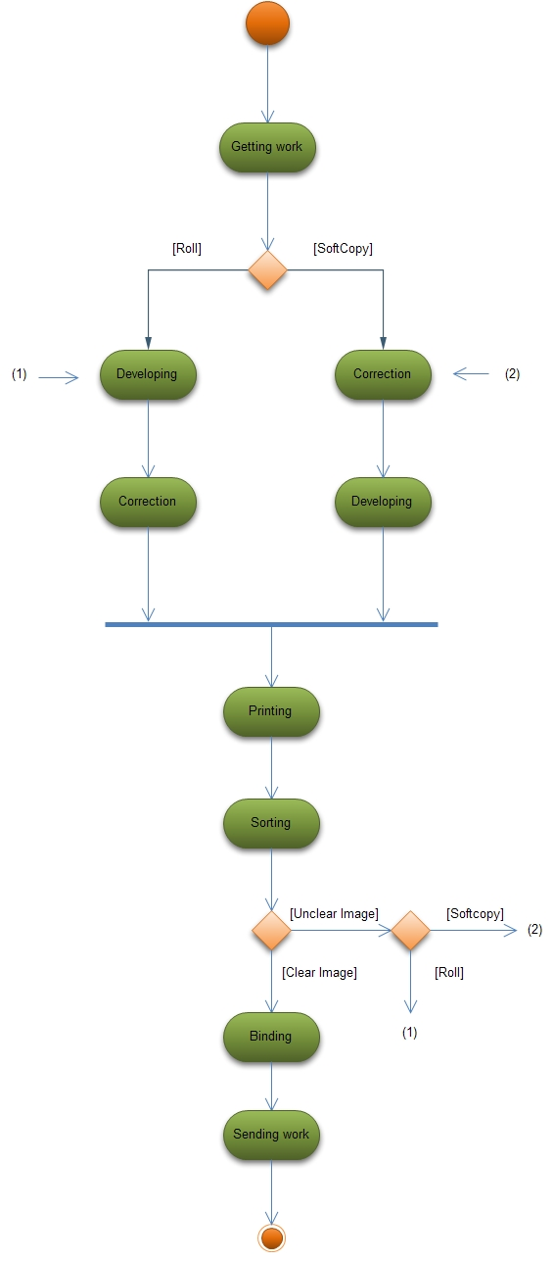

1. **Purchase Department**

As name suggest main work of Purchase Department is to buy materials as per requirement of the different departments of Photography Studio.

MAIN OBJECTIVES :

* To maintain uninterrupted flow of materials to support the schedules.
* To procure materials economically at a cost consistent with the quality and service required. However, generally all purchases may be attempted at the lowest cost.
* To develop and maintain good buyer-seller relationship.
* To sign contract with companies to get material at lowest price.
* To maintain reputation and credibility in the market by fair dealings and payments.

WORK FLOW :

* In studio different departments like Capture department, Editing Department, Designing Department, Printing Department, Binding Department etc. sends their requirements to the Purchase Department. According to their requirement they provide the materials from market as early as possible.
* First, each department of studio makes their requirement list and sends it to the Purchase Department. Like in studio, if photographer needs some type of camera then he/she informs about it to Purchase Department. Photographer makes one file in which he/she writes the specification of camera and sends it to the Purchase Department. They also specify the time limitations so that Purchase Department has an idea about how much time they have to provide material asked in file. Likewise all departments make file for required materials and send it to Purchase Department.
* After getting file from respective department, the staff of the Purchase Department starts working on it. First they check the time limit so that they know the necessity of the material for the respective department.
* They check whether studio has any contract with any company for that product or not.
* If studio has already signed contract with any company for that product then Purchase Department gives order to that company for required product and inform company about date on which they want delivery like if studio has contract with any camera company then photographer has to use that company’s cameras. If that company doesn’t make such camera which photographer needs then and then only then Purchase Department order for it to other store. Same procedure will be done for each department.
* If studio doesn’t have contract with any company for require materials then first the staff of Purchase Department starts to do market study. Like they search for that product to buy it at least price. They do negotiation with provider companies or stores. Sometimes, if that material will be needed in future than they sign contract with that company which provide best quality at least price. So, by signing such contract studio can have material at least price in future and every time quality of the material is also same. And if studio has contract for material then they will get delivery faster. And flow of material also proper. Example: If Developing and Printing Department needs Photosensitive Paper then they send type, quantity and other detail about paper to Purchase Department. If studio doesn’t have contract with any company which provides Photosensitive Paper then Purchase Department signs contract with that company which provide best quality at least price. They signs contract because Printing Department needs Photosensitive Paper daily. So, it’s job of Purchase Department to provide it regularly. So, by signing contract studio will get delivery regularly.
* After, getting material Purchase Department pays money to Provider Company and sends their bills to Accounts Department. So that they can add entries to accounts.

As above, we have written its job of Purchase Department To develop and maintain good buyer-seller relationship. By establishing such relationship studio can have material at best price, and quality and flow will be maintain in future.

Purchase Department has one more responsibility to maintain reputation and credibility in the market by fair dealings and payments. If they don’t do fair dealings in contract then studio’s reputation will be down in market so, no one will sign contract with studio in future so they will have to face problems in future to buy material. They also have to pay regularly after getting material to maintain studio’s reputation and credibility.

**Business Actors:**

Material Provider Company

Sales Manager

Account Department

**Business Workers:**

Staff

**Use case Diagram**

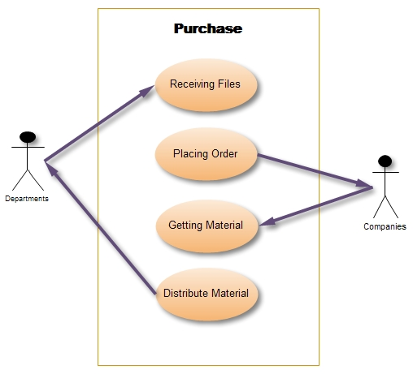

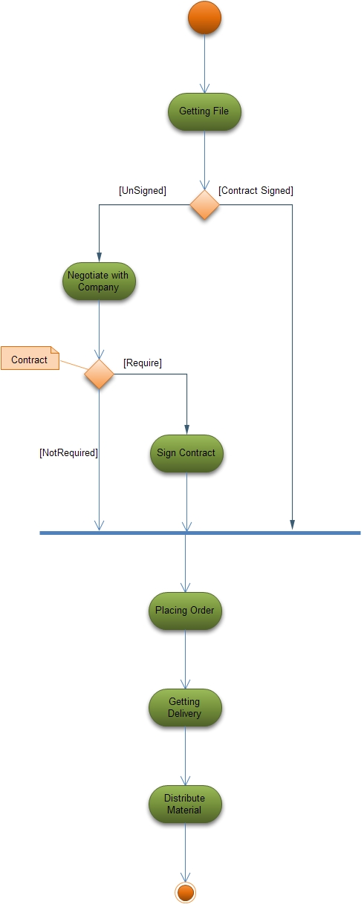

1. **Accounts Department**

Main work of Accounts Department is to maintain Studio’s account and generate financial reports.

# MAIN OBJECTIVES :

* To handle general accounts.
* To prepare financial reports.
* To pay tax according to governments rules.
* To pay salary to staff of studio.

WORK FLOW :

* Accounts Department gets all bills from Sales Department and Purchase Department. According to bills they add entries in respective accounts.
* Mainly, the bills from Sales Department are represent income of Studio and bills from Purchase Department represent expense of the Studio.
* By calculating such deference Accounts Department finds the Profit/Loss of Studio and sends report to owner of Studio. Some other reports like total income and expense of Studio, Ratio of expense on different materials etc. These types of reports will be very helpful to owner to develop his/her Studio.
* Accounts Department pays taxes regularly as per government rules. They always try to save tax.
* Accounts Department also pays salary to staff regularly and adds these entries as expense on staff in accounts.

**Business Actors:**

All Departments

Executive Director

**Business Workers:**

Staff

**Use case Diagram**

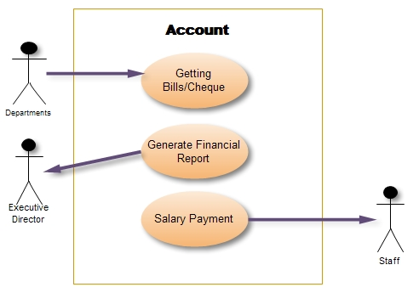

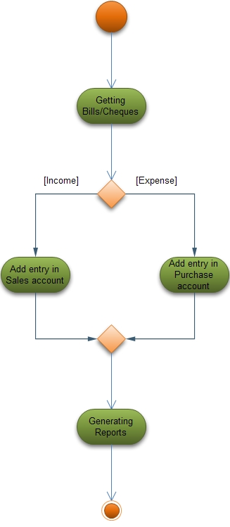

Resources:

* Memories Studio
* Expert wedding Photographers

Mr. Jayprakash Patel

Mr. Prakash Tilokani

* Jenny color Lab, Raopura
* Editor

Mr. Jitu Bhavsar

* Internet

**Thank You**

**Group Members:**

Zoebali Maknojia (50)

Zankhan Joshi (38)

Disha Shah (88)

Nikki Punjabi (78)